Singapore Night Festival

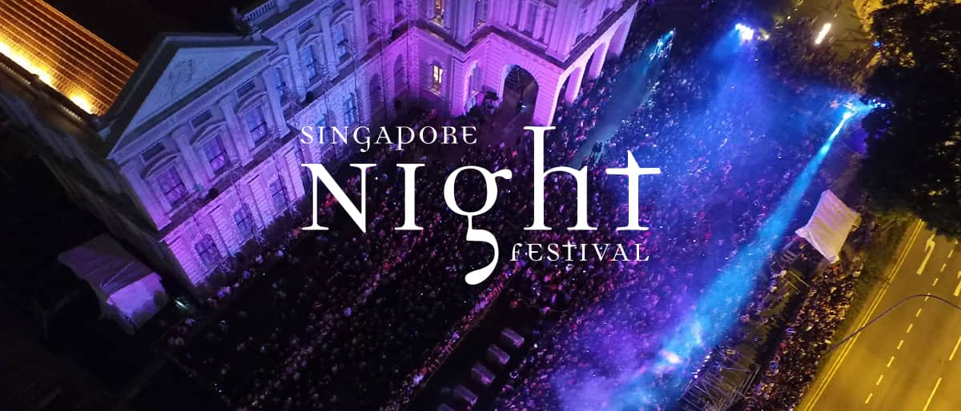

Reimagine the night at Singapore Night Festival 2019 as the Bras Basah.Bugis district transforms into an ethereal wonderland over two weekends this Aug.

Watch the façade of iconic landmarks spring to life in brilliance, familiar spaces surprise with artistic expressions, and animated storytellers enchant the crowd.

Promising something for everyone, one can look forward to an exciting line-up of arts, heritage and cultural experiences brought together by partners and stakeholders in the district.

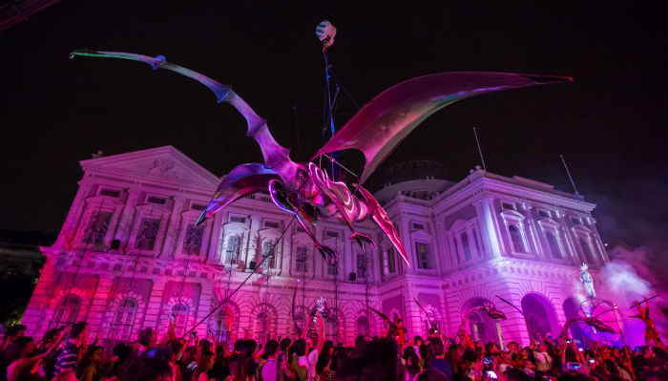

From traditional performances to original work of the street artists, Singapore Night Festival has it all. Held at Bras Basah Bugis in August, this festival attracts a lot of tourists every year and so it is one of the most popular Singapore festivals 2020.

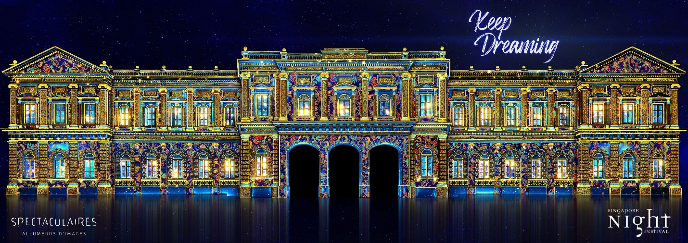

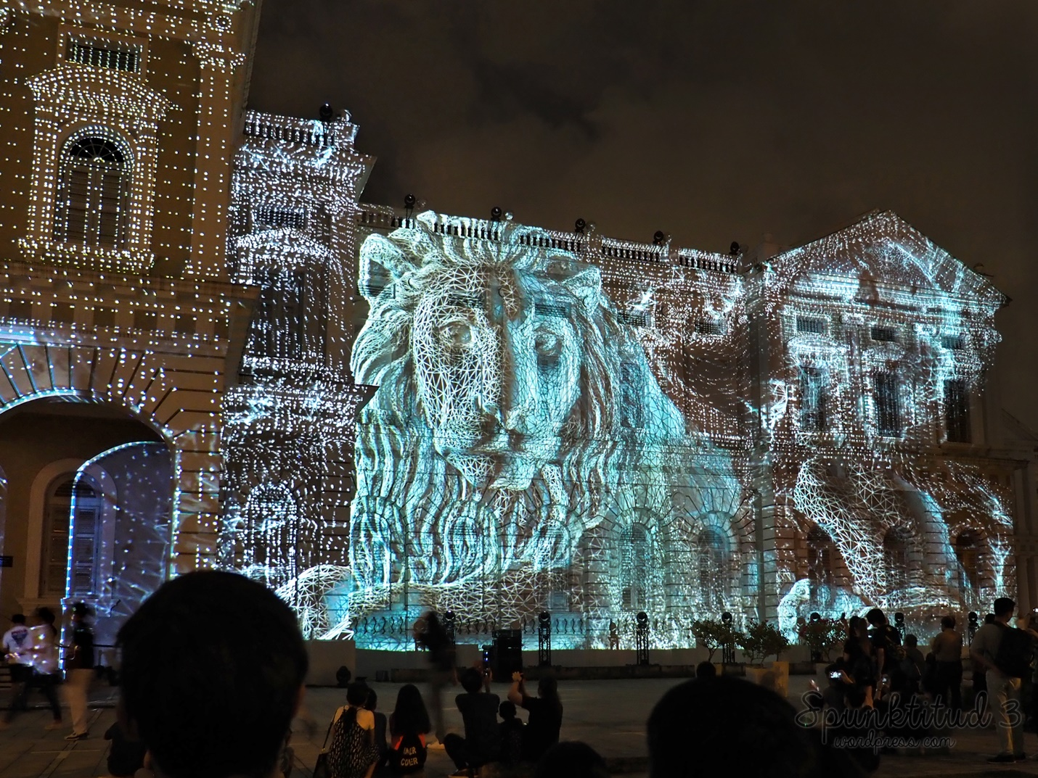

**Don’t miss:**The night performance and activities organised for couples.  
**When:**Yet to be announced.